AGENDA
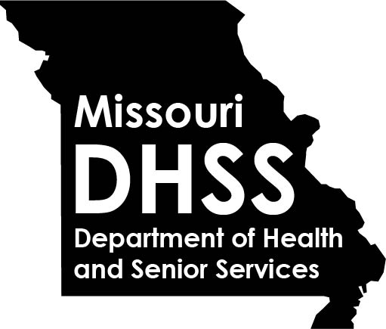

REGIONAL PUBLIC HEALTH MEETING

June 2, 2021
1:00 p.m. – 4:00 p.m.
Virtual via WebEX

1:00 p.m. – 1:15 p.m. | Welcome/OVERVIEW & UPDATES |  | DCPH Leadership
1:15 p.m. – 1:45 p.m. | eletronic health record  Panel Discussion |  | LPHA Panelists
1:45 p.m. – 2:15 p.m. | MoALPHA LEGISLATIVE/MEMBER UPDATES  - 2021 Bill Activity  - LPHA Authority  - LPHA & Legislator Relationship  - Communication |  | Diane Weber, Executive Director  and/or MoALPHA Member Representative  Missouri Association of Local Public Health Agencies  Moalpha2004@yahoo.com
2:15 p.m. – 2:45 p.m.  2:45 p.m. – 3:00 p.m. | For the Health of Missouri, Help us Hit all 115!  Discussion regarding future communication with dhss |  | Shirley Farrah, Assistant Dean, MU Nursing Outreach and Teaching,  Professor, MU Sinclair School of Nursing  FarrahS@missouri.edu  Lynelle Phillips, Assistant Professor and Extension Nurse Specialist, Department of Public Health/School of Health Professions MU Extension Service  phillipslm@health.missouri.edu  DHSS and LPHAs
3:00 p.m. – 4:00 p.m. | Change is Constant: Leading through Change |  | John Thomas, Chief People Officer  DHSS, Office of Human Resources  John.Thomas@health.mo.gov
4:00 p.m. | ADJOURN

