If You Have Diabetes or Heart Disease,
the Flu could Kill You
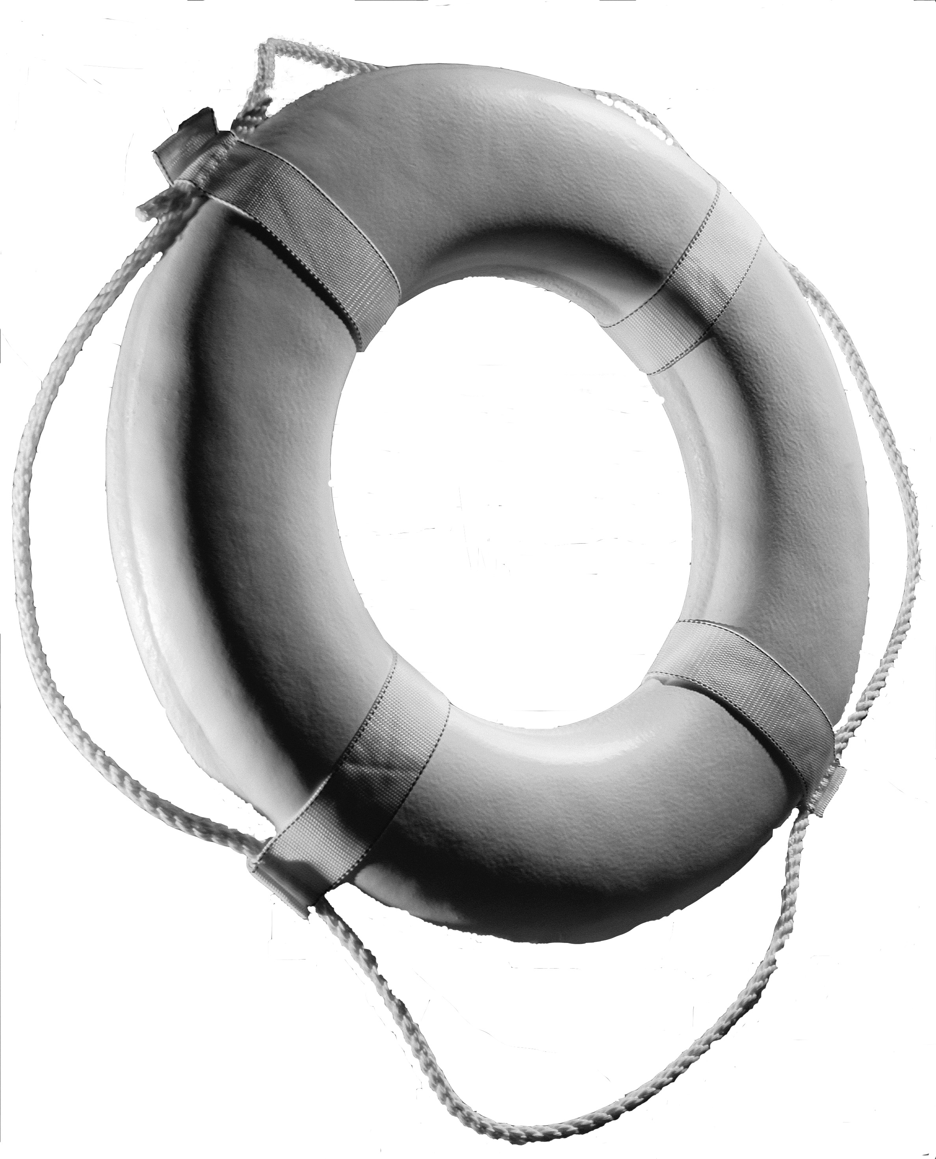

Each year when the flu strikes, about 200,000 people in the United States have to go to the hospital. About 36,000 people even die because of the flu. For people with a chronic health problem, like diabetes or heart disease, the flu can be more than aches and pains. It can mean being sick longer, having to spend time in the hospital, or even risk death. Ask your doctor for a life-saving flu shot for you and those closest to you. Prevention is your lifeline to health.

The Flu Shot? It’s like a Life Preserver when you have a chronic health problem.

If You Have Diabetes or Heart Disease,
the Flu could Kill You

Each year when the flu strikes, about 200,000 people in the United States have to go to the hospital. About 36,000 people even die because of the flu. For people with a chronic health problem, like diabetes or heart disease, the flu can be more than aches and pains. It can mean being sick longer, having to spend time in the hospital, or even risk death. Ask your doctor for a life-saving flu shot for you and those closest to you. Prevention is your lifeline to health.

The Flu Shot? It’s like a Life Preserver when you have a chronic health problem.

If You Have Diabetes or Heart Disease,
the Flu could Kill You

Each year when the flu strikes, about 200,000 people in the United States have to go to the hospital. About 36,000 people even die because of the flu. For people with a chronic health problem, like diabetes or heart disease, the flu can be more than aches and pains. It can mean being sick longer, having to spend time in the hospital, or even risk death. Ask your doctor for a life-saving flu shot for you and those closest to you. Prevention is your lifeline to health.

The Flu Shot? It’s like a Life Preserver when you have a chronic health problem.

If you have health problems, protect yourself from flu and pneumonia

- You need a flu shot every year.
- You absolutely cannot get the flu from a flu shot.
- If you have health problems, you could have a higher risk of getting pneumonia.
- Talk to your doctor about a pneumonia shot.
- Most people only need one pneumonia shot in a lifetime.
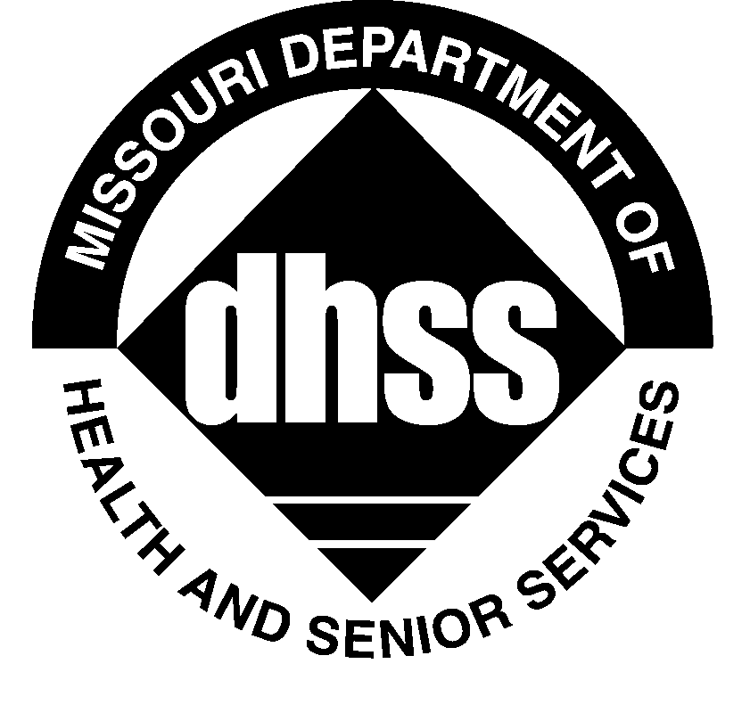
Call your doctor or local health department
for a flu shot clinic near you.

www.dhss.mo.gov/Influenza/

If you have health problems, protect yourself from flu and pneumonia

- You need a flu shot every year.
- You absolutely cannot get the flu from a flu shot.
- If you have health problems, you could have a higher risk of getting pneumonia.
- Talk to your doctor about a pneumonia shot.
- Most people only need one pneumonia shot in a lifetime.
Call your doctor or local health department
for a flu shot clinic near you.

www.dhss.mo.gov/Influenza/

If you have health problems, protect yourself from flu and pneumonia

- You need a flu shot every year.
- You absolutely cannot get the flu from a flu shot.
- If you have health problems, you could have a higher risk of getting pneumonia.
- Talk to your doctor about a pneumonia shot.
- Most people only need one pneumonia shot in a lifetime.
Call your doctor or local health department
for a flu shot clinic near you.

www.dhss.mo.gov/Influenza/

